# <https://github.com/rvsp/typescript-oops/blob/master/Practice/Movie.md>

The class Movie is stated below. An instance of class Movie represents a film. This class has the following three properties:

* title, which is a String representing the title of the movie
* studio, which is a String representing the studio that made the movie
* rating, which is a String representing the rating of the movie (i.e. PG­13, R, etc)

1. Write a constructor for the class Movie, which takes a String representing the title of the movie, a String representing the studio, and a String representing the rating as its arguments, and sets the respective class properties to these values.

Ans:

class Movie{

    constructor(title,studio,rating){

        this.title = title;

        this.studio= studio;

        this.rating = rating;

    }

}

1. The constructor for the class Movie will set the class property rating to "PG" as default when no rating is provided.

Ans:

class Movie{

    constructor(title,studio,rating = "PG"){

        this.title = title;

        this.studio= studio;

        this.rating = rating;

    }

}

1. Write a method getPG, which takes an array of base type Movie as its argument, and returns a new array of only those movies in the input array with a rating of "PG". You may assume the input array is full of Movie instances. The returned array need not be full.

Ans:

class Movie {

    constructor(title, studio, rating = "PG") {

        this.title = title;

        this.studio = studio;

        this.rating = rating;

    }

    getPG(arr) {

        let newArr=[];

        for (let i = 0; i < arr.length; i++) {

            if(arr[i].rating = "PG");

            newArr.push(arr[i]);

        }

        return newArr

    }

}

d) Write a piece of code that creates an instance of the class Movie with the title “Casino Royale”, the studio “Eon Productions”, and the rating “PG­13”

Ans:

let film = new Movie( "Casino Royale","Eon Productions"," PG­13");

# https://github.com/rvsp/typescript-oops/blob/master/Practice/class-circle.md

Circle - Class

Convert the UML diagram to Typescript class. - use number for double

[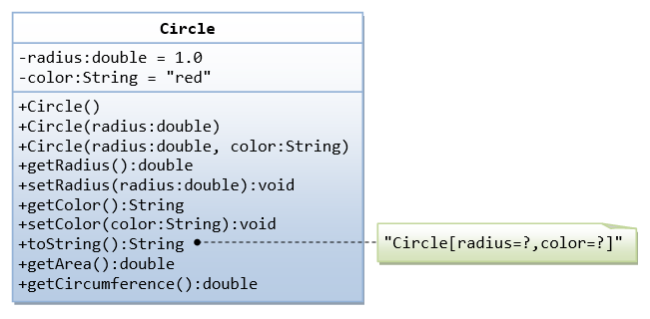](https://github.com/rvsp/typescript-oops/blob/master/images/ClassDiagram_Circle.png)

Ans:

class Circle {

    constructor() {

        var radius;

        var color;

    }

    getRadius() {

        return this.radius;

    }

    setRadius(radius = 1.0) {

        this.radius = radius || 1.0;

    }

    getColor() {

        return this.color;

    }

    setColor(color = "red") {

        this.color = color;

    }

    toString() {

        return (`Circle[radius=${this.radius},color=${this.color}]`);

    }

    getArea() {

        return this.radius * this.radius * 3.14;

    }

    getCircumference() {

        return 2 * 3.14 * this.radius;

    }

}

# Write a “person” class to hold all the details.

Ans:

class Person {

    constructor(name, place, age, address, qualification) {

        this.name = name;

        this.place = place;

        this.age = age;

        this.address = address;

        this.qualification = qualification;

    } }

# Write a class to calculate uber price.

class Uber {

    constructor(price) {

        this.price = price;

    }

    priceCalc(km){

        return this.price*km;

    }

}